Types of Polygons:
http://www.mathsisfun.com/geometry/polygons.html

Congruency:
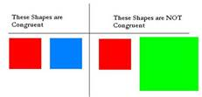
http://www.sheppardsoftware.com/mathgames/geometry/shapeshoot/SSCongruentSimilar.htm

